CERVICAL ROM IMPROVEMENT AFTER MULLIGAN MOBILIZATION TECHNIQUE

Elena CHETAN*, Alin MESTEREAGA*, Dan Ioan STOIA*
* POLITEHNICA University Timisoara, Mihai Viteazu nr.1, dan.stoia@upt.ro,
chetan_elena@yahoo.com, mestereagaalin@yahoo.ro,

Abstract. The paper presents an exploratory research on cervical spine mobility. It focuses on range of motion (ROM) rehabilitation after applying Mulligan mobilization technique on a lot of 6 healthy subjects. The Mulligan techniques used in mobilization were both SNAG and NAGS in order to reduce the number of trials needed when using a single mobilization technique. The ROM of the subjects were recorded before and after mobilization, using an objective, ultrasound based, measuring system. The data were processed by extracting the representative angular complexes for each subject in each test. In order to give some statistical validation of the data, averages, standard deviations and frequencies were computed. The results were presented both tabular and graphically, expressing the average improvements of the rotation angles. The study presents the rotation data only, because the mobilization technique was focused mainly on this direction of movement. The conclusions of the study include two aspects: the angular improvement and the modification of movement frequencies.

Keywords: Mulligan mobilization, cervical ROM, motion analysis, angular improvement, ultrasound system.

1. Introduction

In 2009, Saíz-Llamosas JR et all. enroll thirty-five asymptomatic patients in a study for investigating if the application of myofascial induction technique on the cervical spine lead to enhancement of cervical range of motion. The technique was targeted to the nuchae ligament. They obtained larger intervals for flexion-extension and lateral movement while the rotation movements record no improvements [1].
Alund et.all (2009) establishes a correlation between the conventional gravity goniometer and an electrogoniometer in cervical motion. The gravity goniometer provides good reproducibility for some movements, while it returns unsatisfactory results for other. Anyway, the electrogoniometric recordings showed good correlation with the motion amplitudes measured radiographically. They conclude that three-dimensional motion analysis affords a more objective evaluation of common neck disorders [2].
În 2008, Pamela Teys et.all. propose a study on 24 subjects in order to investigate the initial effect of Mulligan’s mobilization technique on shoulder ROM. They determined a significant and clinically meaningful improvement on both ROM and pressure pain threshold. The improvement occurred immediately after the mobilization technique. The duration of the mobilization effect was not covered by the study, this being a future perspective [3].
In 2013, Langenfeld et. all. propose an alternative to cervical spine manipulation, in order to reduce the associated risks. The alternative consists in an electromechanical device that produces high frequency - low amplitude vibrations. The objective of the study was to compare the short and long term effect of manual versus mechanical assisted manipulation. The study focuses on pain evaluation rather than on objective mobility evaluation [4].
The assessment of the cervical motion can be done using various measurement tools [5]. Instrumented techniques were developed recently in order to obtain reliable results in spine mobility evaluation [6].
¶

2. Materials and methods
The methods used in the study refer to mobilization technique and data recording. These approaches are detailed in the following sub sections of the paper.
The study involves 6 voluntary subjects, three men (lot II) and three female (lot I) raging from 22 to 25 years old, which have no medical records regarding the cervical spine pathology. The movements recorded in the study were flexion-extension, left-right rotation and lateral bending before and after the mobilization.

2.1. Mulligan mobilization technique
The mobilization of the human skeleton using manual movement techniques were discovered and developed by F.N.Z.S.P. (Hon), Dip.M.T. Brian Mulligan, New Zealand. The techniques are simple and effective in pain free of the musculoskeletal disorders. The joint repositioning technique allows restoration of the mobility functions and pain abolition [7].
The mulligan techniques are used to treat a variety of injuries and pain in human spine. It can be applied at any level: cervical, thoracic and lumbar and also on the upper and lower extremity injuries.

The technique is based on movement application and sustain on the direction of natural apophyseal glides. Being an external movement applied on the patient’s natural ROM, it is considered as passive physiological. There are three particular techniques in Mulligan concept: Natural Apophyseal Glides (NAGS), Sustained Natural Apophyseal Glides (SNAGS) and Mobilization with Movement (MWM). All of these are used in treatment of musculoskeletal injuries and degenerative pathology [8]
SNAG mobilization. Having the subject in seated position, the therapist places his distal phalanx of the thumb on the end of the spinous process of the vertebra (above the suspected movement limitation site). The other thumb is placed above the first one to reinforce the movement. The rest of the therapist’s fingers are preventing the neck from flexing, by holding firm the mandible. The spinous process is moved up, in the direction of treatment plane (figure 1). While the facet glide is being maintained, the subject slowly rotates his head in the restrictive direction. In order to ensure that the mobilization direction remains along the treatment plane, the therapist’s hands must follow the subject movement. This procedure is repeated 5 to 10 times in order to achieve good results [9].

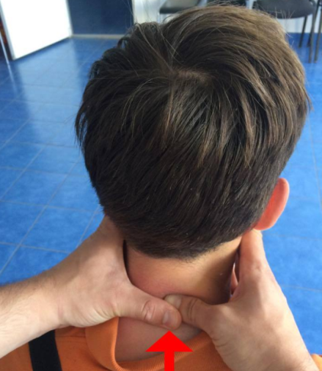
Figure 1 SNAGS mobilization technique for subject 1

NAGS mobilization. The therapist is positioning at the right side of the subject, having contact with antero-lateral surface of the subject’s right shoulder. While the subject’s head is sustained by the therapist’s chest, the right forearm is positioned on subject’s left temporo-mendibular joint. The fingers configuration on the subject’s spine is: right little finger is placed under the spinous process of the immobilized vertebra; right index third and fourth fingers are wrap around the occiput (figure 2). The required glide along the treatment plane is given by pushing up and forward toward the eyeball [9].

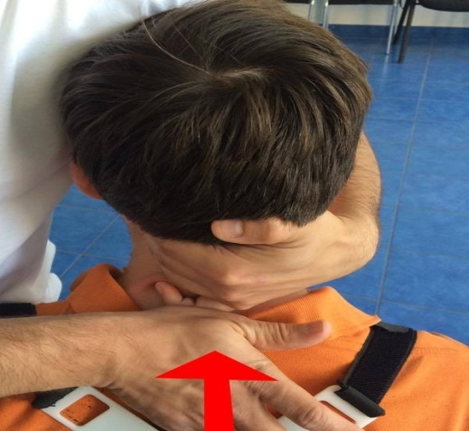
Figure 2 NAGS mobilization technique for subject 1

The decision of executing both techniques rely on achievement of faster results, avoiding in this way the errors that can be associated with the measurements conducted over the large time intervals.

2.2. ROM recordings and data processing
The instrumented motion analysis was used for determining the kinematical parameters of the cervical movement. The cervical marker configuration of Zebris ultrasound system was use before and after the mobilization in order to measure the cervical angles in all planes.
For reducing measurement errors, the subjects were placed on the same position (sitting on a chair) every time they were measured. Also, the reference and principal markers were positioned rigorously every time, using skin marks on the body (figure 3).

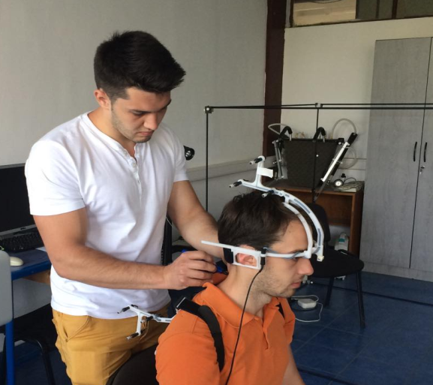
Figure 3 Marker positioning on subject 1

Each subject was asked to execute 10 movement cycles in two distinctive trials of recording, for each type of movement. The procedure was applied also after mobilization.

3. Results and discussions
The cervical mobility data were recorded for all three movements, but only the results for rotation were processed and presented in the paper. The focus on rotation movement was caused by the larger amplitude obtained by mobilization.
In order to present the recorded data, these were selected, extracted and averaged for each subject in each trial. In these procedures, incomplete cycles or cycles belonging to evasive movements were eliminated. The best five cycles for each subject in each trial was averaged.
Because the significant difference between the movements velocities of each subject, the data cannot be presented as time function. The maximum values for each cycle were extracted instead, together with the time that they were recorded.
By extracting several time periods for the movement cycles, an average period was computed. From these findings, the average movement frequencies were calculated (Table 1).

Table 1 Movement frequencies in rotation
Lot | Subjects | Average movement frequency f [Hz] and standard deviation
Lot | Subjects | Before | After
I | S1 | 0.42±0.004 | 0.37±0.011
I | S2 | 0.26±0.003 | 0.25±0.005
I | S3 | 0.48±0.019 | 0.38±0.016
II | S1 | 0.30±0.007 | 0.28±0.014
II | S2 | 0.35±0.008 | 0.32±0.002
II | S3 | 0.34±0.005 | 0.23±0.036

By considering the results from the table 1, we can observe that in rotation ROM the movement frequencies are decreasing in every subject after the mobilization. This can be a measure of longer time needed for accomplishing the larger amplitudes (as we will see).
In the figures 4 and 5, the average differences between the mobilization results and initial results of the lot I, are presented. It can be observed that the amplitudes were significantly increased in all subjects, no matter the direction of the movement (left or right). Inside the results of individual subjects, an unbalanced left-right improvement was observed.

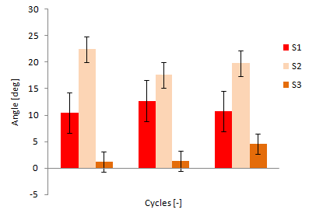
Figure 4 Right rotation improvements on lot I

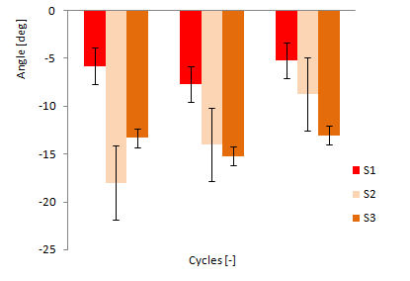
Figure 5 Left rotation improvements on lot I
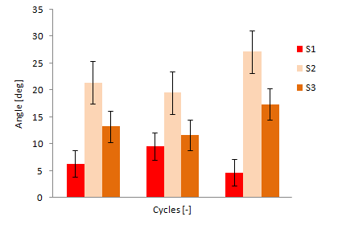
Figure 6 Right rotation improvements on lot II

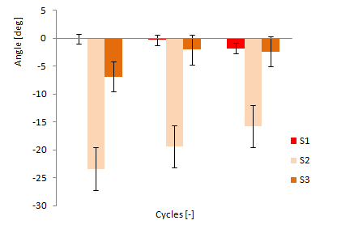
Figure 7 Left rotation improvements on lot II

In the figures 6 and 7, the angular average differences of the lot II are presented. The results can be evaluated in the same way as for the first lot. Anyway, in the left direction of rotation, some subjects of the second lot seams to experience less improvement.

3. Conclusions
By examining the small statistic lot we can affirm that all angular amplitudes are increasing after the mobilization technique.
The movement frequencies are decreasing in all cases and can be explained by the larger time intervals required for subject to achieve larger amplitudes (by maintaining a constant angular velocity).
The study’s results provide no information about long time preservation of the ROM gained by mobilization technique.

References
1. Saíz-Llamosas JR, Fernández-Pérez AM, Fajardo-Rodríguez MF, Pilat A, Valenza-Demet G, Fernández-de-Las-Peñas C, Changes in neck mobility and pressure pain threshold levels following a cervical myofascial induction technique in pain-free healthy subjects, J Manipulative Physiol Ther., Vol 32(5):352-7, 2009 Jun.
2. Alund M., Larsson SE., Three-dimensional analysis of neck motion. A clinical method. Spine (Phila Pa 1976). 1990 Feb;15(2):87-91. PubMed PMID: 2326717
3. Teys P., Bisset L.M., Vicenzino B., The initial effects of a Mulligan's mobilization with movement technique on range of movement and pressure pain threshold in pain-limited shoulders, Manual therapy, 03/2008; 13(1):37-42. DOI: 10.1016/j.math.2006.07.011.
4. Langenfeld A., Humphreys B.K., de Bie R.A., Swanenburg J., Effect of manual versus mechanically assisted manipulations of the thoracic spine in neck pain patients: study protocol of a randomized controlled trial, Current Controlled Trials ISRCTN88585962, Trials. 2015 May 27;16(1):233. doi: 10.1186/s13063-015-0763-5.
5. Castro W., Sautmann A., Schilgen M. and Sautmann M., Noninvasive three-dimensional analysis of cervical spine motion in normal subjects in relation to age and sex: An experimental examination, Spine, vol. 25 (4), February 2000, pp.443-449
6. Stoia, D.I., Toth-Tascau, M., Cervical Spine Mobility Using 3D Ultrasound-Based Measuring System, International Conference on Advancements of Medicine and Health care Through Technology, Book Series: IFMBE Proceedings, Vol. 26, pag. 391-394, 2009
7. ***: http://www.bmulligan.com. Accessed: 2015-06-01
8. ***: Mulligan Physical Therapy, http://integrehab.com/mulligan-physical-therapy-ct/, Accessed: 2015-06-01
9. Mulligan Concept. Spinal Mobilization Techniques And Self Treatment Techniques, https://dl.dropboxusercontent.com/u/36225545/PAP/Script/Cervical. Accessed: 2015-06-01

